**WORKING**

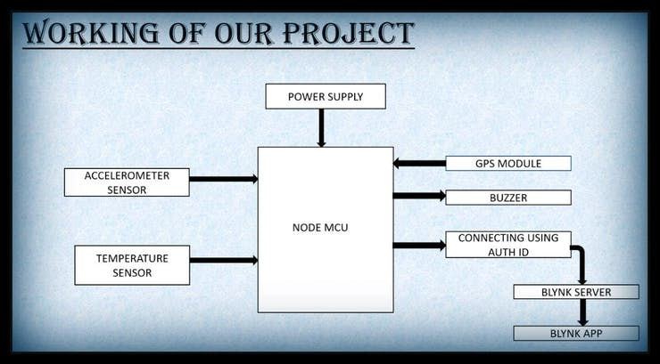

BLOCK DIAGRAM

**Values displayed on the application:**

* Latitude and longitude value
* google maps.
* Temperature value
* X, Y and Z coordinates
* LCD

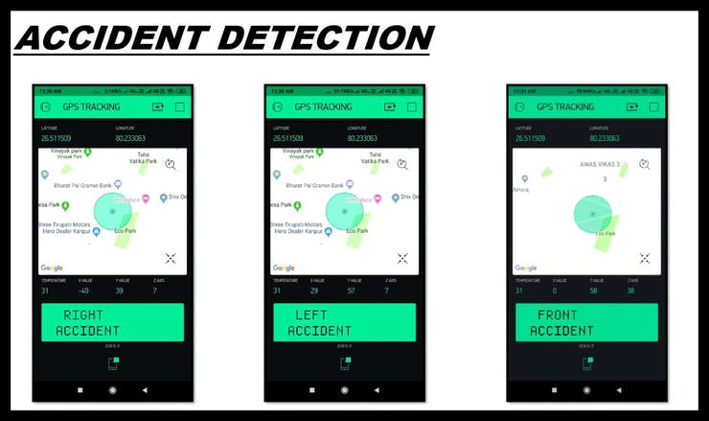

ACCIDENT DETECTION

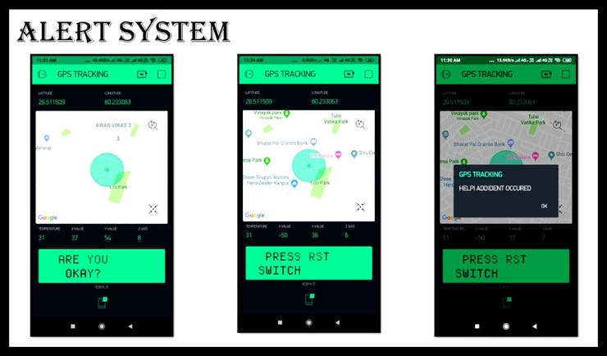

**INTERFACING GPS WITH NODEMCU:**

* The GPS module is connected to Node MCU.
* The Power is given to NodeMCU by battery and the NodeMCU starts the WIFI.
* The GPS module takes some time to capture location details once it is powered on.
* The GPS module receives the data from satellite and gives output in standard string format.
* The string contains different parameters separated by commas like longitude, latitude, altitude, time
* It provides output serially on Tx pin with default 9600 Baud rate.
* The NodeMCU gets the output and send to the blynk App